**Numerical Solution to the Laplace equation using Finite Difference Method**

**Subhadeep Bej - 20PH40048**

**1.Introduction:** The Laplace equation is a second order partial differential equation that governs variety of physical phenomenon such as temperature distribution in solids, fluid flow, distribution of electrostatic potential in a region. In this essay we will find a numerical solution to the Laplace equation for electrostatic potential using Finite Difference Method (FDM). To illustrate a solution, we will consider the distribution of electrostatic potential in a two dimensional region, where the value of the potential is known at the boundaries. This is also known as Dirichlet type boundary condition.

The expression for Laplace equation,

Where, $φ$ is the value of potential at any local point in a given domain.

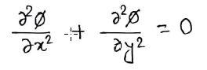In cartesian coordinates,

**2.Finite Difference Method:** Let us consider a two dimensional rectangular region. And, as mentioned before values of potential at all points of the four boundaries are already known. We want to find how the potential vary inside the region, given the boundary conditions.

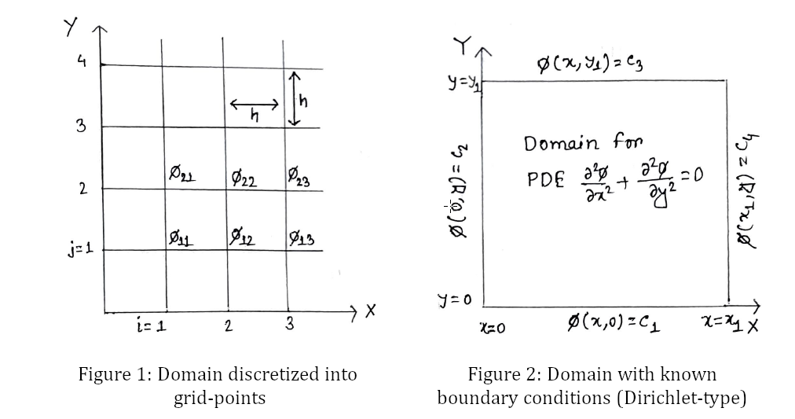To find a numerical solution for the potential, we will discretize the whole domain into grid points separated by extremely small distances. Then, we will find a solution at each of those grid points**.**

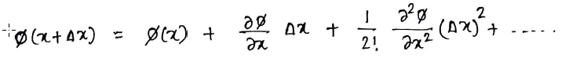We know Taylor series approximation of a function,

Forward difference,



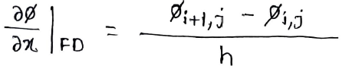In the discretized scenario this can be written as,

Backward difference,

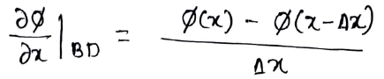

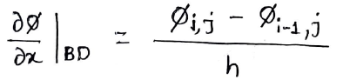In the discretized scenario,

We have taken the separation between any two consecutive grid points to be same, $∆$ x = $∆$ y = h

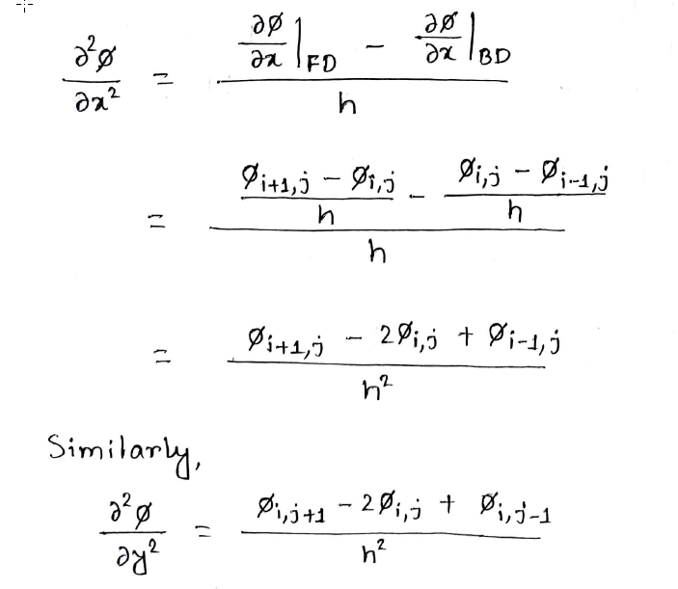Therefore,

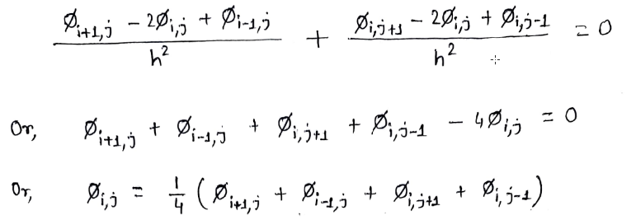Substituting in the Laplace equation,

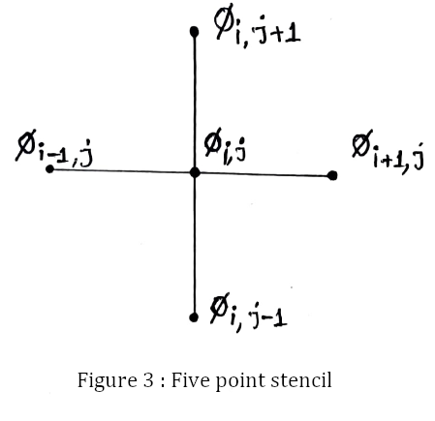This shows that the value of $φ$ at any grid-point is just the average value of potentials at surrounding grid-points. And, the grid-point together with its four neighbours forms a five point stencil.

We will use the above formula in an iterative manner to approximate the value of $φ$ at each grid-point. This method is known as Gauss-Seidel method.

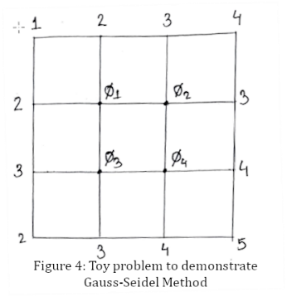**3.Gauss-Seidel Method:** In this section we will use a toy problem to demonstrate an iterative method of solving systems of linear equations, called the Gauss-Seidel method.

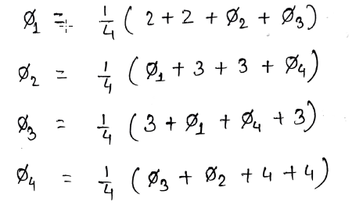In this toy problem we have four equations, one for each of the four interior points and values at the boundaries are known. We will use the formula for $φ_{i,j}$ to find a solution at each of the interior grid points.

It is interesting to note that the grid points at the corners do not contribute to the above equations. So our approximation near the corners may seem a bit inaccurate. However, one can always compensate for that by choosing the grid points to be very closely spaced so that error near the corners is as small as possible.

We start the iteration process by guessing the value of $φ$, wherever it is not known, to be 0.

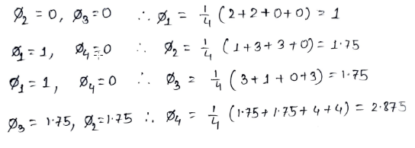Iteration 1:

For the next iteration we will use the values obtained in the previous iteration.

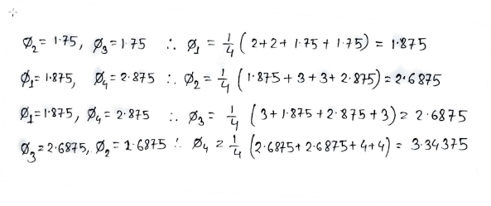Iteration 2:

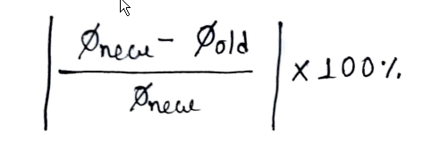We can continue iterating over and over again until we reach a satisfactory value for the maximum relative error. The relative error is given by,

|  |  |  |  |  |  |
| --- | --- | --- | --- | --- | --- |
| Iteration No. | $$∅_{1}$$ | $$∅_{2}$$ | $$∅_{3}$$ | $$∅_{4}$$ | Max relative error |
| 1 | 1 | 1.75 | 1.75 | 2.875 | - |
| 2 | 1.875 | 2.6875 | 2.6875 | 3.3437 | 0.46666 |
| 3 | 2.3437 | 2.9218 | 2.9218 | 3.4609 | 0.20000 |
| 4 | 2.4609 | 2.9804 | 2.9804 | 3.4902 | 0.04761 |
| 5 | 2.4902 | 2.9951 | 2.9951 | 3.4975 | 0.01176 |
| 6 | 2.4975 | 2.9987 | 2.9987 | 3.4993 | 0.00293 |
| 7 | 2.4993 | 2.9996 | 2.9996 | 3.4998 | 0.00073 |
| 8 | 2.4998 | 2.9999 | 2.9999 | 3.4999 | 0.00018 |
| 9 | 2.4999 | 2.9999 | 2.9999 | 3.4999 | 0.00004 |
| 10 | 2.4999 | 2.9999 | 2.9999 | 3.49999 | 0.00001 |

Table: Gauss-Seidel method (ten successive iteration)

It is evident that with each iteration the relative error gets smaller and smaller and our approximation gets better and better. Thus, we can use the Gauss-Seidel algorithm to find a solution to the equations obtained using finite difference method.

**4.Finding a Numerical Solution in Python:** In this section we will mimic the whole process in Python to find near-perfect solutions for any arbitrary boundary conditions of Dirichlet type.

Below we have discretized a 2 metre by 2 metre rectangular region into a 20x20 grid and chosen the boundaries at the top, bottom, left and right to be at 20 volts, 40 volts, 10 volts and 30 volts respectively.

import matplotlib.pyplot as plt

import numpy as np

xvalues = np.linspace(0, 20, 20)

yvalues = xvalues

X, Y = np.meshgrid(xvalues, yvalues)

Phi = np.zeros_like(X)

# Boundary conditions

Phi[0, :] = 20 #top boundary

Phi[-1, :] = 40 #bottom boundary

Phi[:, 0] = 10 #bottom boundary

Phi[:, -1] = 30 #bottom boundary

for k in range(500):

for i in range(1, len(xvalues)-1):

for j in range(1, len(yvalues)-1):

Phi[i][j] = 0.25 * (Phi[i+1][j] + Phi[i-1][j] + Phi[i][j+1] + Phi[i][j-1]

colormap = plt.cm.jet

colorinterpolation = 50

# Changing the aesthetics

ticklabels = [i for i in np.arange(0, 2.1, 0.25)]

plt.gca().xaxis.set_ticklabels(ticklabels)

plt.gca().yaxis.set_ticklabels(ticklabels)

plt.xlabel('Width of the domain (metres)')

plt.ylabel('Height of the domain (metres)')

#Plotting

plt.contourf(X, Y, Phi, colorinterpolation, cmap = colormap)

plt.colorbar( )

plt.show( )

plt.savefig('potential_distribution.png') #Saving the image

This is how the potential distribution looks like:

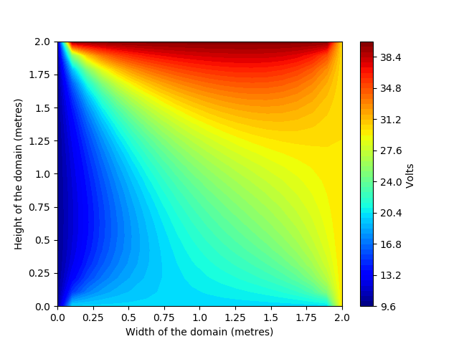

References :

1. [The code used can be found here](https://github.com/sbhhdp/laplace-equation/blob/master/the-laplace-eqn.ipynb).
2. Numerical Solution of the Laplace Equation: Electrostatic Potential by Fernando Mesa
3. Finite Difference Method for Laplace Equation : M. L. Dhumal, S. B. Kiwne